MSDS 6371 ANALYSIS QUESTION: Summer 2025 Midterm Exam
HONOR CODE: By taking this test and typing your name below, you are:
- …agreeing on your honor and in accordance with the SMU Honor Code (but more importantly, on your honor) to not have communicated with anyone, during the exam, in this class or outside of this class, that could have helped obtain answers to these questions. “Communicated” means by any medium including talking, phone, Slack, Discord, email, text, Facetime, Instagram, snap chat, etc. You are also agreeing
- … no text was copied or pasted from sources other than your own.
Please type your name here which serves as your signature _________Johnny C. Vogt_______________________
Directions and Submission: Simply save your answers to this document and upload them to the Final Exam assignment on 2DS with your name in the file name. You should type your answers directly into this document. You may do any mathematical work by hand and include a picture of that work in this document or simply type those calculations into this document.
Unless otherwise specified, assume $α=0.05$ and 95% confidence.
- (1 pts each)Complete the table with the appropriate symbol or description:
Symbol | Description
$\underline{x}$ | Sample Mean
s² | Sample variance
$σ^{2}$ | Population Variance
s | Sample standard deviation
$μ$ | Population Mean
n | Sample Size

- Who said, “All models are wrong but some are useful?” (2 pts)
  - George E.P. Box

- We conducted an experiment in which we had 4 groups (1,2,3 and 4) and we had 5 observations per group. A plot of the data is below along with the assumed normal distributions of the responses per group. Note, we are also assuming that the variance is the same for each normal distribution. An ANOVA was run and some of the results are in the table below the plot.
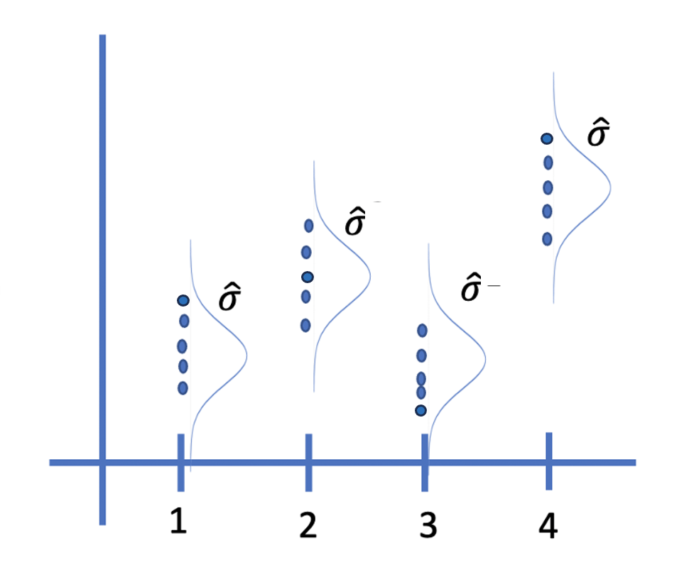
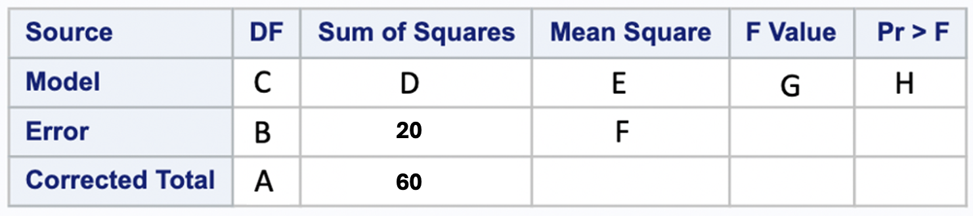
Indicate the corresponding values referenced above in the table and plot as well as the MSE, R², $\hat{σ}$ and the estimate of the pooled standard deviation (1 pt each):
A: 19
B: 16
C: 4
D: 40
E: 10
F: 1.25
G: 8
H: 0.0009653
MSE: 1.25
R²: .666667
$\hat{σ}$: 1.118
What is the estimate of the pooled standard deviation: 1.118

- Matching (1 pt each) Letters can be used more than once!
Assume we are testing the claim that the mean heart beats per minute (bpm) of males is 9$3 bpm$.
$H_{o}: μ=93bpm$
$H_{a}: μ≠93bpm$
- Rejecting Ho when the true mean bpm is 93bpm. _a__

- The probability of failing to reject Ho when the true mean bpm is 9$7$ . __h_

- When the effect size goes from 10bpm to 5bpm, what happens to the power? ___n___

- When the significance level (alpha) goes from .05 to .01 what happens to the power? __n_____

- Failing to Reject Ho when the true mean bpm is $87$. _b__

- The probability of rejecting Ho when the true bpm is $87$ . _g__

a. Type 1 Error  b. Type 2 Error  c. R² | d. degrees of freedom  e. $\hat{y}$  f. Power | g. $α$  h. $β$  i. Extrapolation | j. pvalue  k. proportion  l. residual | m. increases  n. decreases

- Ho:$μ=90$
Ha:$μ≠90$
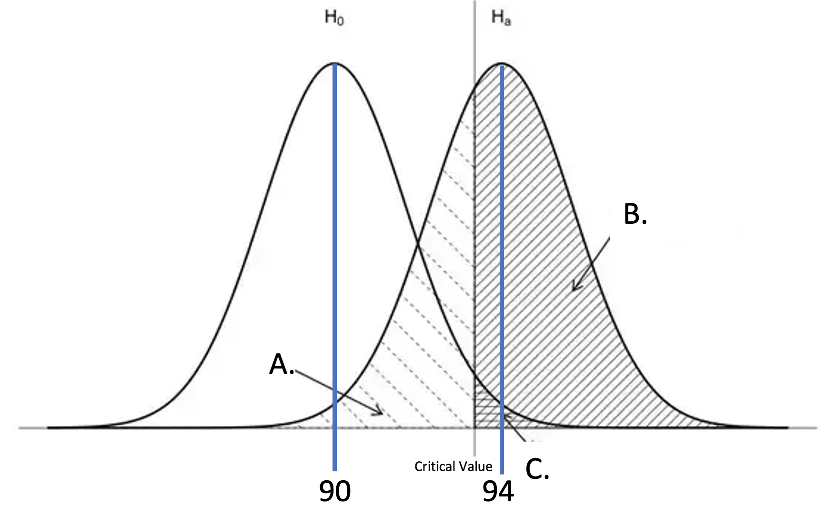
Consider the Ho, Ha and drawing above. Answer a, b and c below from the answer bank in question 4 and answer d with a number. (2 pts each)

- What does A represent?
  - Alpha (g)
- What does B represent?
  - Power (f)
- What does C represent?
  - Beta (h)
- What is the effect size?
  - 90-94

MSDS 6371 ANALYSIS QUESTION: Summer 2025 (55 pts)
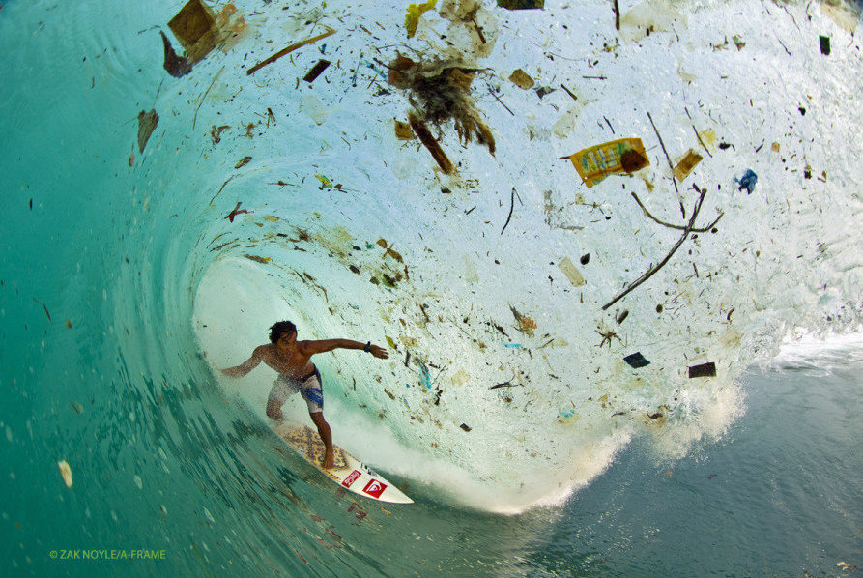
In the past 20 years, scientists have discovered that plastic has become an increasing threat to wildlife in the ocean. It is also thought that with Asia’s rapid growth that there may be more pollution coming from Asia than from the Americas. In order to test this hypothesis, 53 boats were deployed in the West Pacific Ocean and 54 boats were deployed in the East Pacific in order to measure the level of plastic in each region (in ounces). Each boat collected all the plastic present on the surface of the water in a square kilometer at a particular time of the day (or night). The weight of this plastic was recorded in ounces and can be found in the data file provided: plasticEastWest2025.csv.
Interestingly, there is a form of bacteria that is thought to be evolving to actually eat plastic and use it as a source of nutrition. The level of this bacteria in each square kilometer plot (Ideonella sakainesis) was also recorded by each boat recorded in bacterial per milliliter (bpml).
In addition to the plastic and Ideonella sakainesis level in each square kilometer plot, the water temperature of each square kilometer was recorded by each boat as well. Finally, you may assume that the square kilometer “plots” were far enough away from each other that they can be considered independent observations.
For all problems below assume an alpha = .05 level of significance and 95% confidence intervals. Also, you do not need to draw and shade for step 2 of a hypothesis test for these questions. Additionally, please provide confidence intervals when appropriate and possible.
Please put all code either in your response to the problem or in an appendix at the end of the test.
- (25 pts) Conduct a two-sample t-test to test the claim that the mean plastic level (in ounces) is greater in the West Pacific than in the East. You may assume the assumptions are met for this test. For the actual test, please provide the six-step test with a confidence interval and scope of inference that addresses causality (if the result is significant) and the generalizability of the result. In addition, in conducting this test, you are assuming that the standard deviation of the plastic levels in the East and West Pacific are equal. Provide the estimate of this standard deviation. We of course need the most powerful and most appropriate analysis.
  - Hypothesis (East = 2225.3, West = 2125.5)
    - $H_{o}: μE-μW=0$
    - $H_{a}: μE-μW ≠ 0$
  - Significance, Critical Value, and Confidence Interval
    - Alpha = .05
    - Confidence Interval: -123.6 - 323.2
    - Critical Value: +/- 1.96
  - Assumptions and Test
    - Estimated Standard Deviation($\hat{σ}$): 582.7
    - From the prompt, We will continue forward assuming the assumptions are met for the most powerful test, which would be the two-sample t-test. Both regions have a plastic weight distribution that is is fairly normal, but since we have a large number observations for both classes, we are able to assume normality through the Central Limit Theorem. The standard deviations do not match, but we will proceed with caution. Since each boat traveled far from each other, it is safe to assume that each observation is independent from each other.
  - Calculate Test Statistic and P-Value
    - T Value: 0.89
    - P Value: 0.3779
  - Decision:
    - Fail to Reject the Null Hypothesis
  - Conclusion (w/ Scope of Inference)
    - There is not enough evidence to suggest that the East or West regions of the Pacific Ocean have different levels of plastic. At a 95% confidence level, we set our inteveral between -123.6 and 323.6. Given the conditions that the two regions are equal to each other, obtaining a difference of 99.7853 is very likely and discourages us to assume that the regions are different. The pvalue (.3779) of a two-sample t test is not statistically significant enough to assume any decision on difference between the two regions. The results should be taken in consideration with the fact that we proceeded with the most powerful test, given if all the assumptions were met.
    - Since the boats were sent to specific regions, they were not randomly sampled or assigned. This prevents us from generalizing outside of the Pacific Ocean AND making any causal claims of the levels of plastic in the ocean. In this Observational Study, we are only able to make associations and generalize it to only the Pacific Ocean.
- (10 pts) The researcher would now like to investigate if there are differences in mean or median bacteria levels based on the time of day and, if so, they would like to quantify / describe those specific differences. You may assume the assumptions of any tests you run are met for the test(s) you choose. We of course need the most powerful and most appropriate analysis.
  - Hypothesis
    - $H_{o}: μm= μa = μe =μn$
    - $H_{a}: μm ≠ μa ≠ μe ≠ μn$
  - Significance, Critical Value, and Confidence Interval
    - Alpha = .05
    - Critical Value: 3.94
  - Assumptions and Test
    - From the prompt, We will continue forward assuming the assumptions are met for the most powerful test, which would be the ANOVA test and a post-hoc tests (likely a tukey, and maybe a dunnett, if we can visually see if one group is very different than the rest) . Between the each Each time of day, there seems to be varying degrees of spread, so we will continue with caution.
  - Calculate Test Statistic and P-Value
    - F Value: 6.43
    - P Value: 0.0005
  - Decision:
    - Reject the Null Hypothesis
  - Conclusion (w/ Scope of Inference)
    - There is sufficient evidence to suggest that there is at LEAST one group mean is different from the rest of the means. The test provides a very low PValue, which suggest the likelihood of running another study and obtaining similar results are extremely low. We ran the ANOVA with a Post Hoc Tests (Tukey’s and Dunnett’s) and determined that there is a statistically significant difference. In the Dunnett’s it provides a very low pvalue, showing each difference is statistically significant enough to assume that they do not have the same mean.
    - Since the boats were sent to specific regions and sent at particular times, there is no random assignment or sampling. We are unable to make a causal assumption or generalize this past the Pacific ocean. This observational study should only provide associations and data for further study.
- (25 pts) Near the end of the experiment the researchers decided to perform one last study. One researcher had a thought that an experimental enzyme they had been working with might help dissolve plastic in the ocean into inert subcomponents. They didn’t have much time or enzyme so they selected 8 “plots” in the ocean to conduct the experiment. For each plot, the researchers remeasured the plastic in the plot and then applied the enzyme to the water in that plot. They waited 2 hours and then came back to the plot and remeasured the plastic in the plot. The data are recorded in BacteriaEnzymeStudy.csv. Conduct the appropriate test and make sure to provide a clear conclusion as to if there is evidence to suggest that the enzyme is effective in reducing plastic in the ocean. Please address the assumptions of any methods / tests you use in your response / analysis. We of course need the most powerful and most appropriate analysis.
  - Hypothesis
    - $H_{o}: μd= 0$
    - $H_{a}: μd ≠ 0$
  - Significance, Critical Value, and Confidence Interval
    - Alpha = .05
    - Critical Value: +/- 1.96
    - Confidence Interval: 1.47 - 3.4440
  - Assumptions and Test
    - The data isn’t normal, so we performed a log transformation and the data started followed a normal distribution. I went ahead and ran a one-smaple test on the difference between before and after. Since we are used the Log’d data, we will move forward with the center of the distribution being the median. Each observation were far enough from each other to assume independence.
  - Calculate Test Statistic and P-Value
    - T Value: 6.09
    - P Value: 0.0009
  - Decision:
    - Reject the Null Hypothesis
  - Conclusion (w/ Scope of Inference)
    - There is sufficient evidence to suggest that the experimental enzyme actually has an effect. The low p-value is statistically significant enough to assume that there is a difference. The is a very low chance of similar results, given that there is no actual difference between the before and after. Since our study shows a confidence interval of 1.47 - 3.444 and 0 does not fall in the interval, it means that the true population of our study likely is between our 96% confidence interval and very unlikely to be 0
    - There is no random sampling, since they selected 8 plot based on availability and time constraints There is no random assignment either, since the control was the rest of the unselected sites and they were chosen from a lack of resources (time). We are unable to make a causal assumption and generalize this past the Pacific ocean. This observational study should only provide associations and data for further study.

Appendix
#P-Value Calculation for ANOVA table
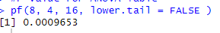

A.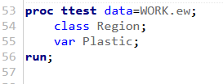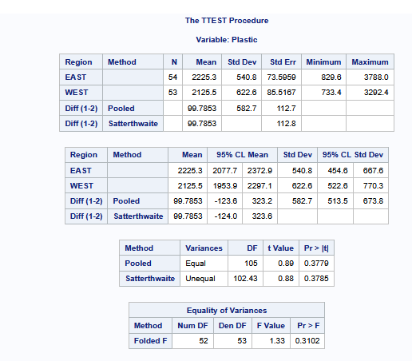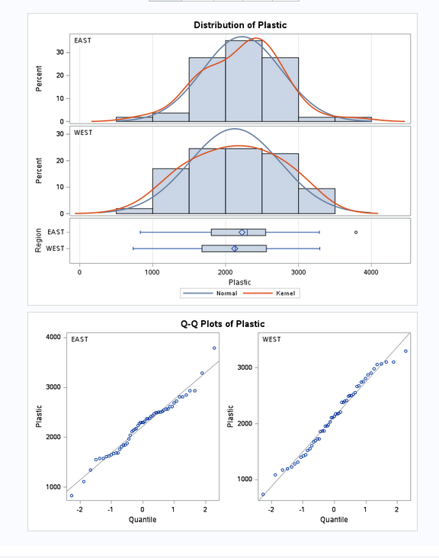
B.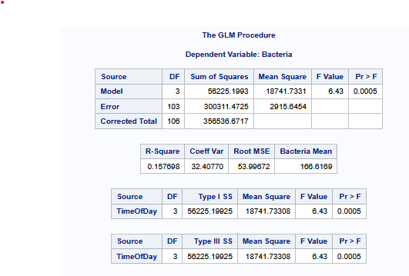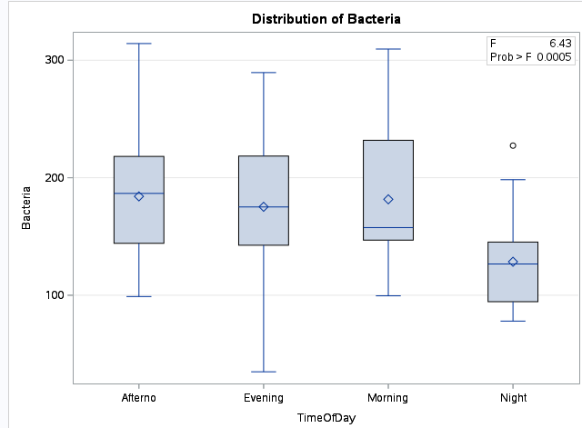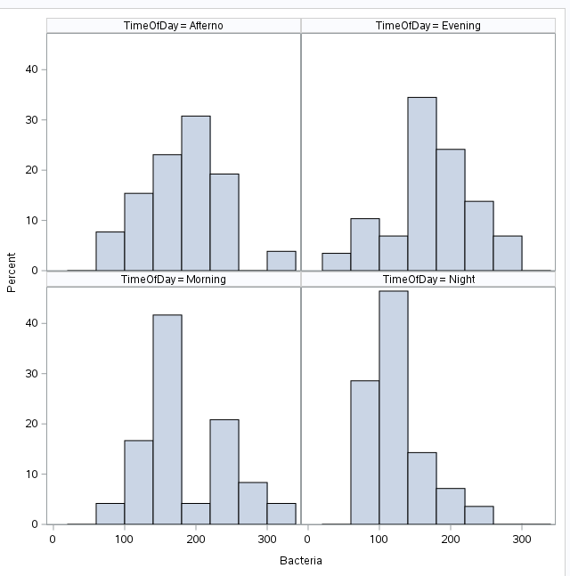
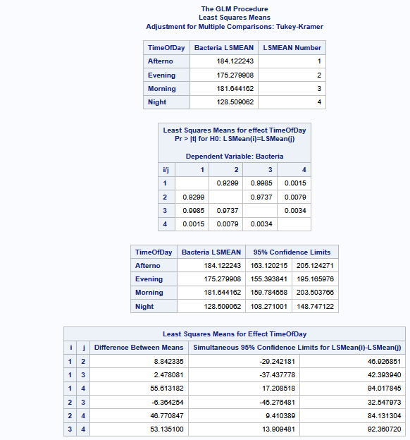
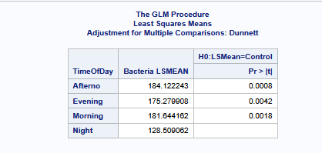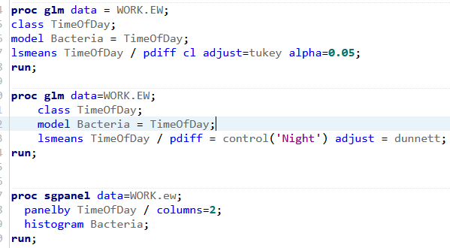

C.
